

**Lab Manual**

**Computer Engineering – Artificial Intelligence**

**B. Tech. Year – II, 5th Semester, Academic Year (2023)**

**Subject Code: 01AI0504**

*Subject Name: Digital Image Processing*

*Name: Basid Al Siddik Shammo*

*Enrollment Number: 92100151052*

**Aim-** Preliminary tutorial on opencv

**Description-** OpenCV (Open-Source Computer Vision Library) is an open-source computer vision and machine learning software library. OpenCV was built to provide a common infrastructure for computer vision applications and to accelerate the use of machine perception in the commercial products. Being an Apache 2 licensed product, OpenCV makes it easy for businesses to utilize and modify the code

**Implementation-** To check if OpenCV is correctly installed, just run the

following commands to perform a version check:

python

>>>import cv2

>>>print(cv2.__version__)

**Result-**

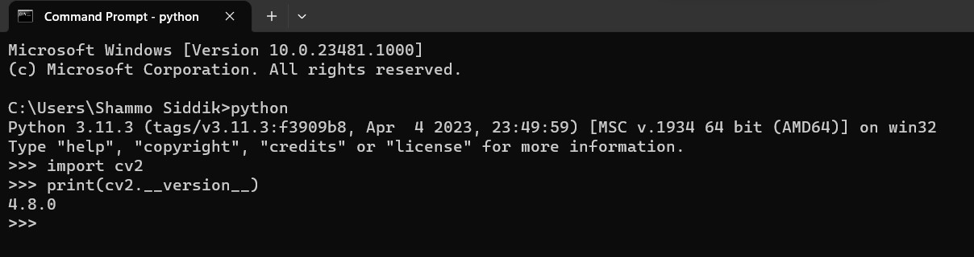

**Conclusion-**